**UNLOCKING INSIGHTS INTO THE GLOBAL AIR TRANSPORTATION NETWORK WITH TABLEAU.**

**NM ID:NM2023TMID06992**

1. INTRODUCTION

OVERVIEW

* The overview section in tableau can unlocking Insights into the global air transportation network by allowing you create visualisation and dashboards based on relevant data. you can import data related to air travel , such as flight routes, passenger numbers, airport and more and use tableau features to analyze and the present this information effectively.

purpose

* The analyzing safety and security data can help identify potential risks and enhance security measures. tableau can be used to visualize and monitor safety and metricks.
* Air transportation allows people to travel quickly and efficiently over long distance , connecting cities and countries, promoting tourism and enabling business and personal travel.

**Problem Definition and Design Thinking**

Empathy map

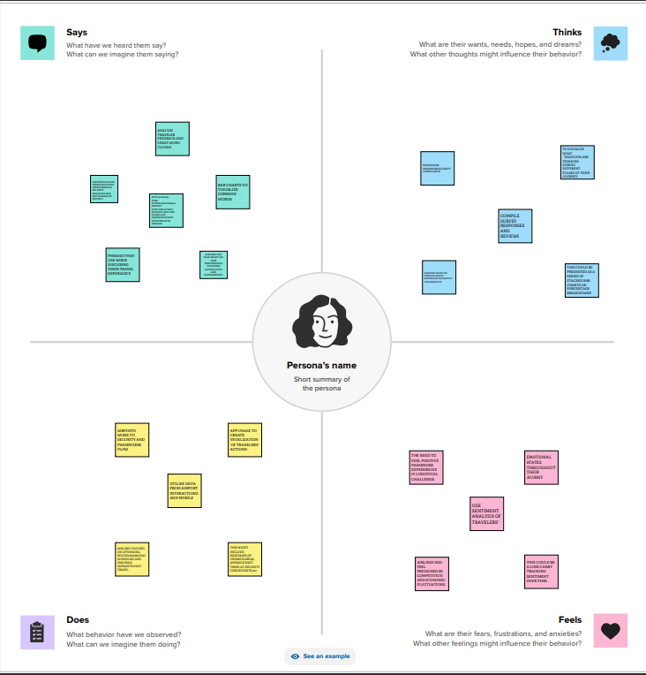

Brainstorm

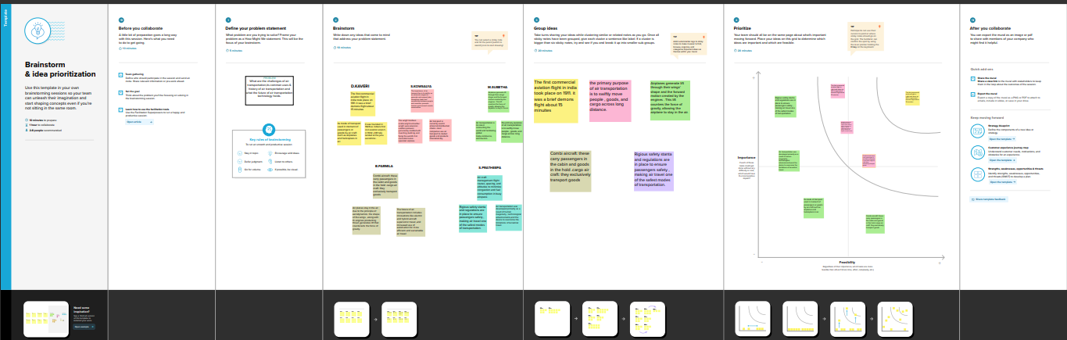

3. Result

Dashboard

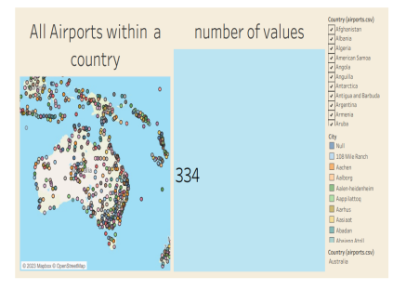 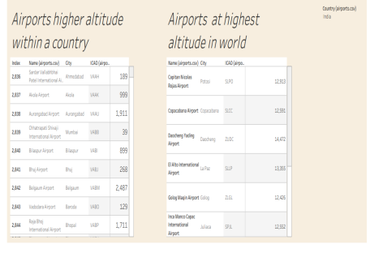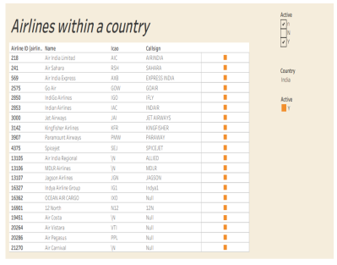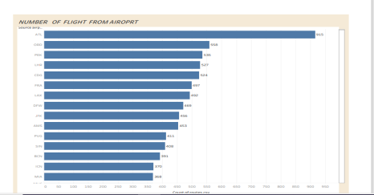

**Story**

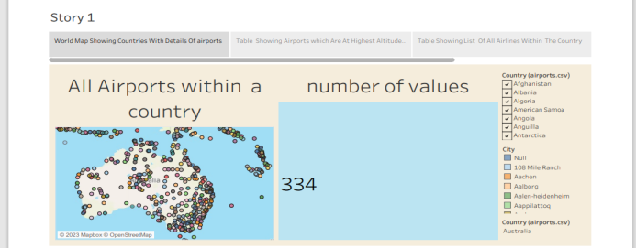

**4. Advantage and disadvantages**

**Advantage:**

* **Air travel is one of the fastest modes of transportation , allowing people and goods to**

**moove quickly across long distance .**

* **Airports are widespread and can reach remote or less accessible locations, connecting region that might be challenging to reach by other means.**
* **Air travel is relatively convenient , with multiple, daily flights to many destinations.**

***Disadvantage***

* ***Airports in major cities often experience congestion can also strain local infrastructure.***
* ***Aircraft produce significant noise polution , especially, near airports ,which can have adverse effects on the quality of life for living in the vicinity.***
* ***Not everyone has equal access to air travel due to financial constraints.***

**5. Applications**

* **Passengers travel to commercial aviation**
* **The tourism industry**
* **Air cargo supports international trade**
* **Air travel is a key tool for diplomacy**
* **Aircraft including specialized transport**

**6. Conclusion**

* **In conclusion , utilizing the tableau to unlock insights into the global air transportation network offers a power full and**
* **versatile approach for data analysis and visualization.through this platform ,we can glean valuable information that aids in understanding.**

**7. Future Scope**

* **As more data sources become available, including real-time data from internet of thinks devices on aircraft, weather and passenger behavior , tableau can facilities the integration.**
* **With growing focus on environmental concerns, tableau can be used t monitor and analyze carbon emission, fuel consumption, and other sustainability metrics.**